Supporting Document

1. **Visuals and Insights**

**I have saved all the useful layers in QGIS as individual GeoPackage files and uploaded them. However, I am concerned that there might be issues opening the documents. Therefore, I have taken screenshots of each page. If you encounter any difficulties opening my files, please feel free to contact me. Thank you!**

* 1. **Figure 1: Heat Vulnerability Index (HVI) for New York City Census Tracts, 2023**

**QGIS Layer: `NYC_HVI_2023_CensusTract`**

**Research Method:**

* Data Source: Heat Vulnerability Index (HVI) data for 2023.
* Visualization Tool: QGIS was used to map the HVI scores for different census tracts in NYC.
* Insight: This map highlights areas with high heat vulnerability, helping to identify where cooling interventions are most needed.

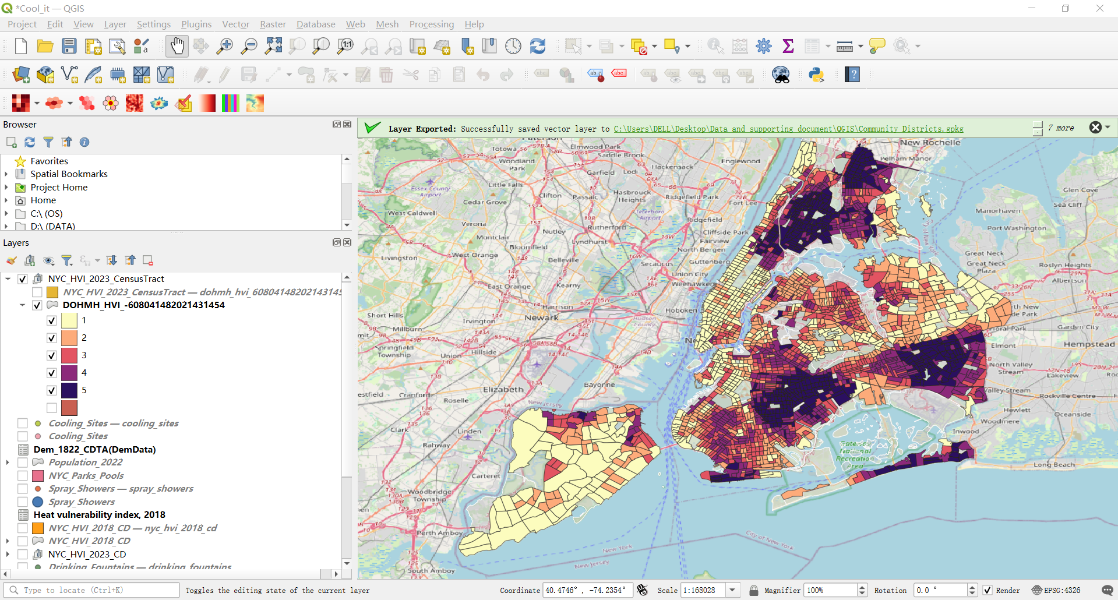

* 1. **Figure 2.Cool it! NYC 2020: Spray Showers Map**

**QGIS Layer: Spray_Showers**

**Research Method:**

* Data Source: Locations of spray showers installed as part of the "Cool it! NYC" project in 2020.
* Visualization Tool: QGIS was used to create a map of spray shower locations across New York City.
* Purpose: To combat high temperatures, NYC Parks activates sprinklers at hundreds of playgrounds across the city when temperatures reach 80 degrees Fahrenheit or higher.
* Accessibility: Spray showers are placed in areas accessible to the public, providing immediate relief from heat.
* Distribution: The map highlights the specific locations of spray showers, indicating areas with higher densities of these cooling facilities.

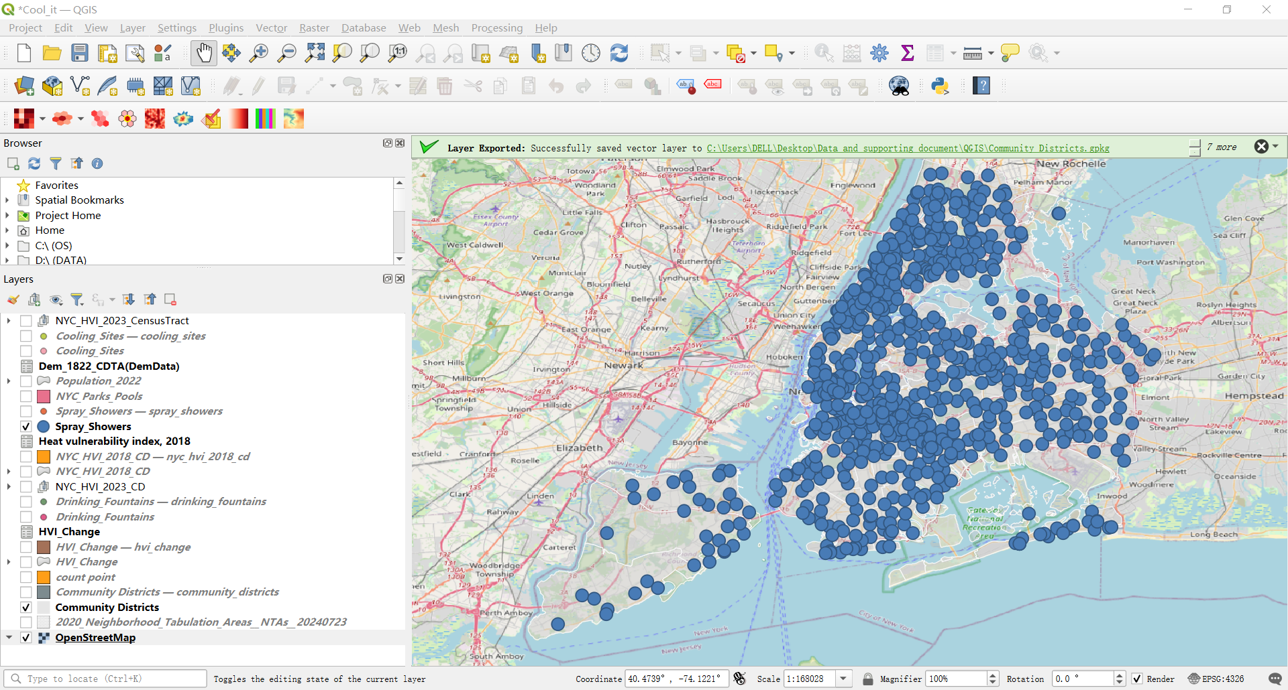

* 1. **Figure 3. Cool it! NYC 2020: Drinking Fountains Map**

**QGIS Layer: Drinking_Fountains**

**Research Method:**

* Data Source: Locations of drinking fountains installed as part of the "Cool it! NYC" project in 2020.
* Visualization Tool: QGIS was used to create a map of drinking fountain locations across New York City.
* Purpose: Thousands of drinking fountains are activated each year, with over 950 located in high-need areas.
* Distribution: The map highlights the specific locations of drinking fountains, showing areas with higher densities of these facilities.

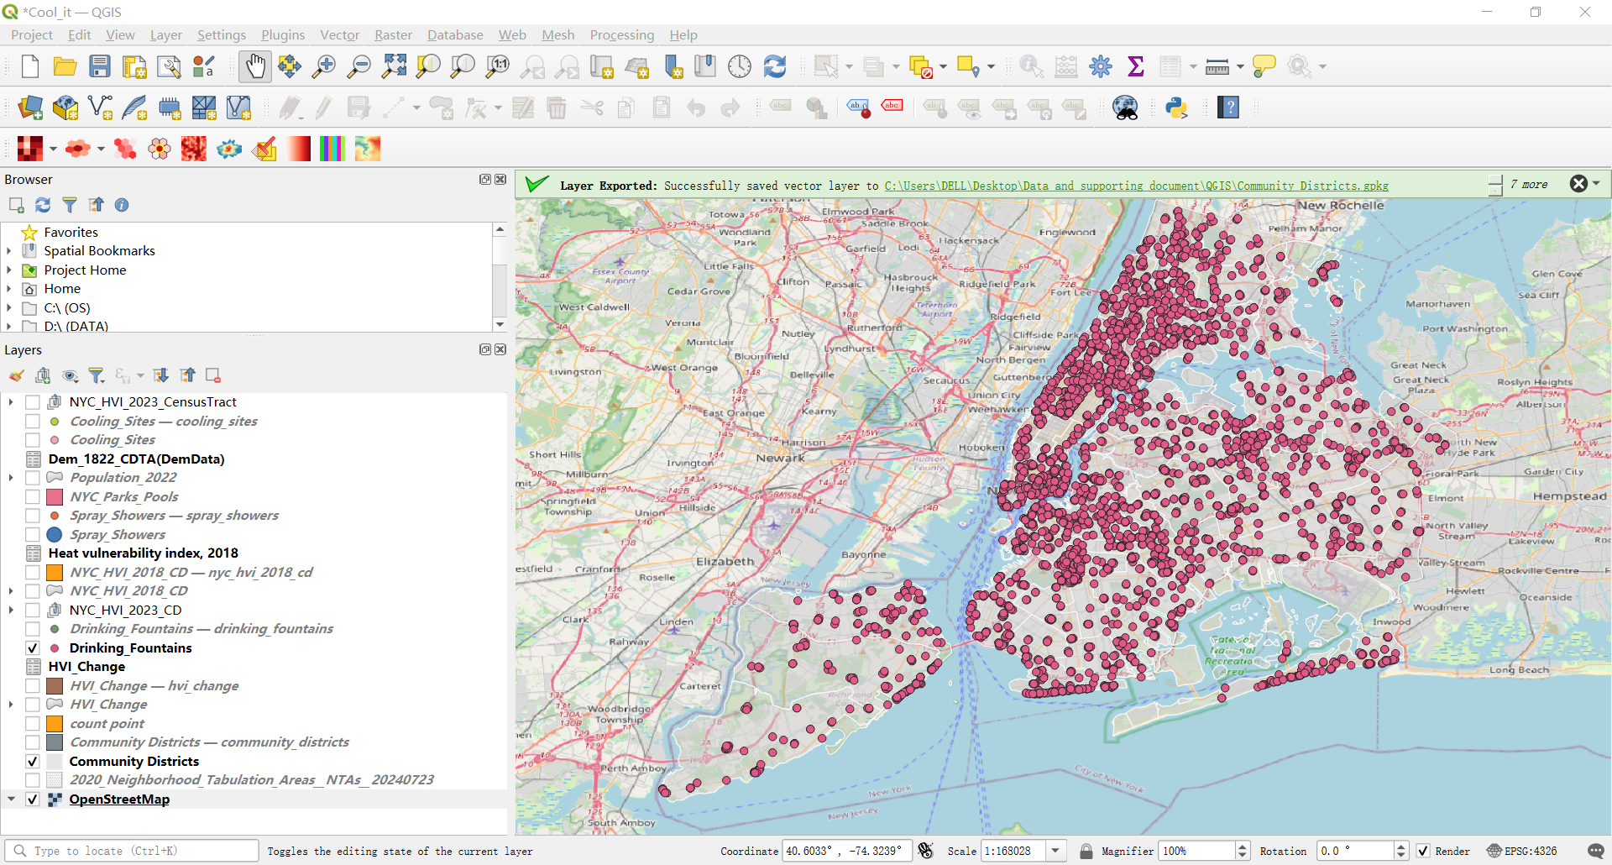

* 1. **Figure 4. Cool it! NYC 2020: Cooling Sites Map**

**QGIS Layer: Cooling_Sites**

**Research Method:**

* Data Source: Locations of cooling sites activated as part of the "Cool it! NYC" project in 2020.
* Visualization Tool: QGIS was used to create a map of cooling site locations across New York City.
* Purpose: During heat emergencies, the City opens cooling centers throughout the five boroughs to provide residents with a safe and cool place to escape the summer heat.
* Distribution: The map shows the specific locations of cooling sites, highlighting areas with higher densities of these facilities. This distribution helps identify regions where cooling resources are available and where more sites may be needed.

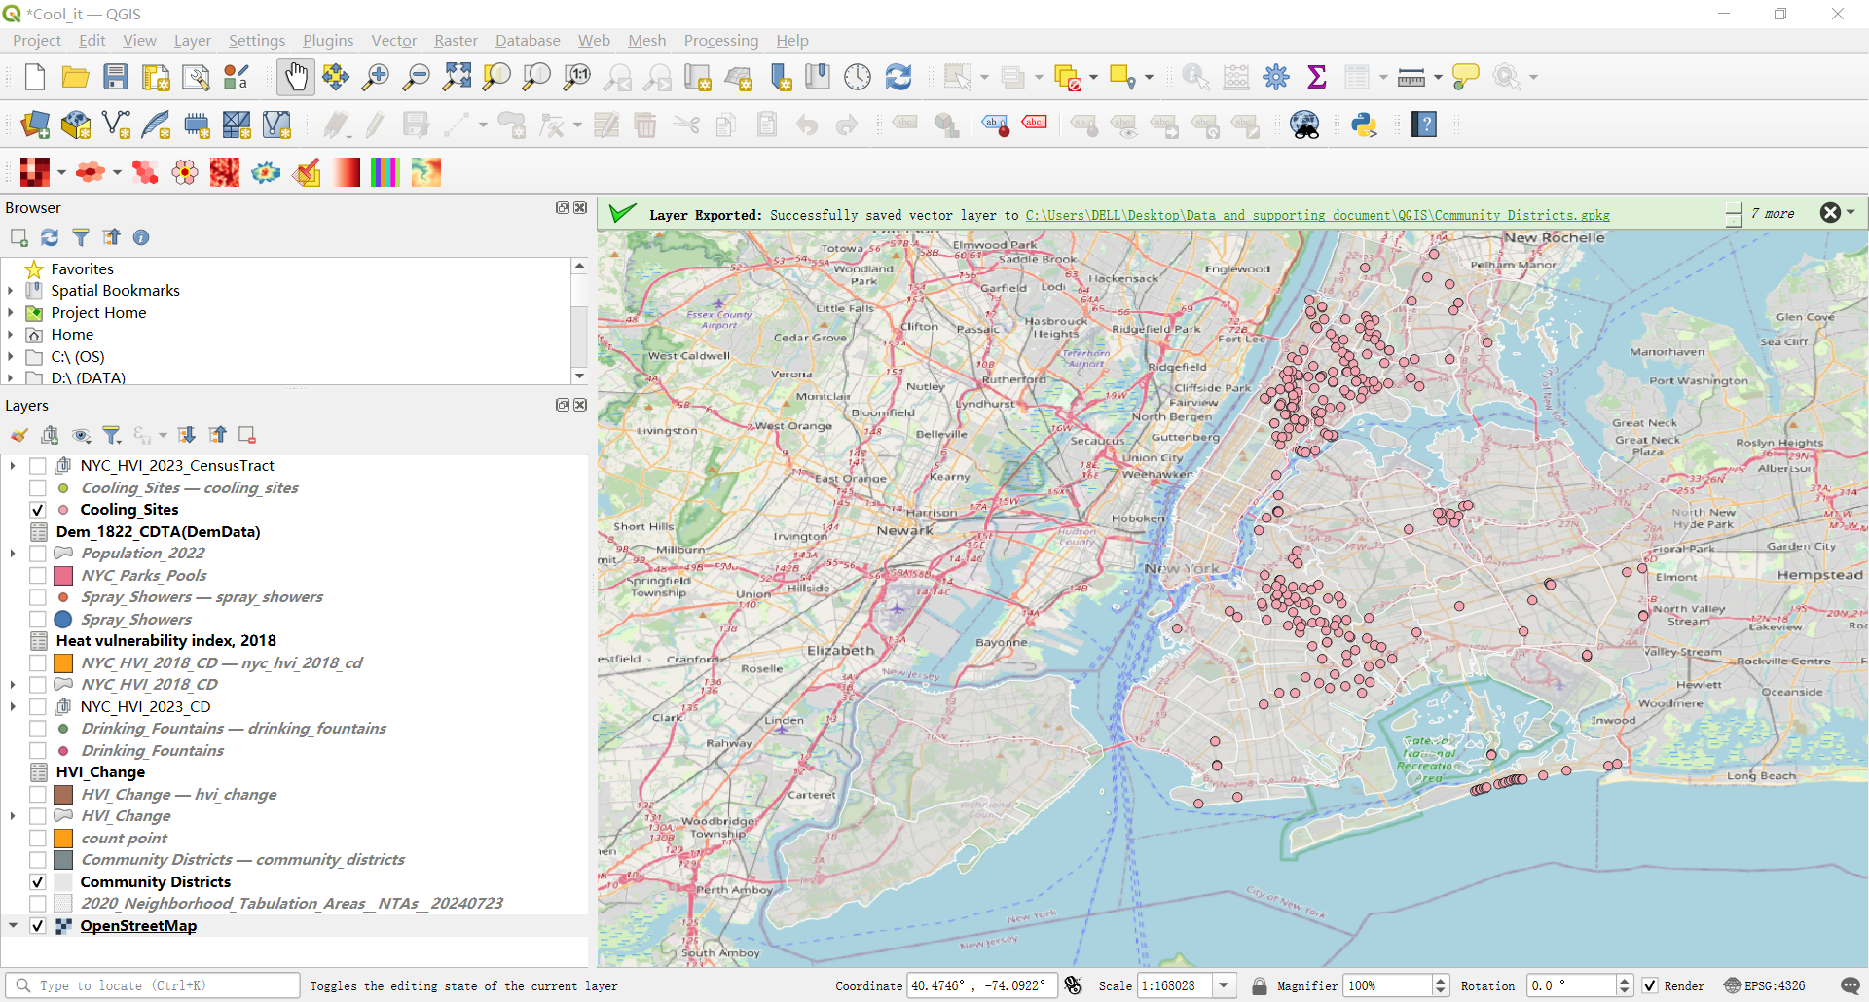

* 1. **Figure 5: Heat Vulnerability Index (HVI) for New York City Community Districts, 2018**

**QGIS Layer: `NYC_HVI_2018_CD`**

**Research Method:**

* Data Source: Heat Vulnerability Index (HVI) data for 2018.
* Visualization Tool: QGIS was used to create the map of HVI scores for 2018.
* Insight: This map serves as a baseline to compare with 2023 data to evaluate the impact of the "Cool it! NYC" project.

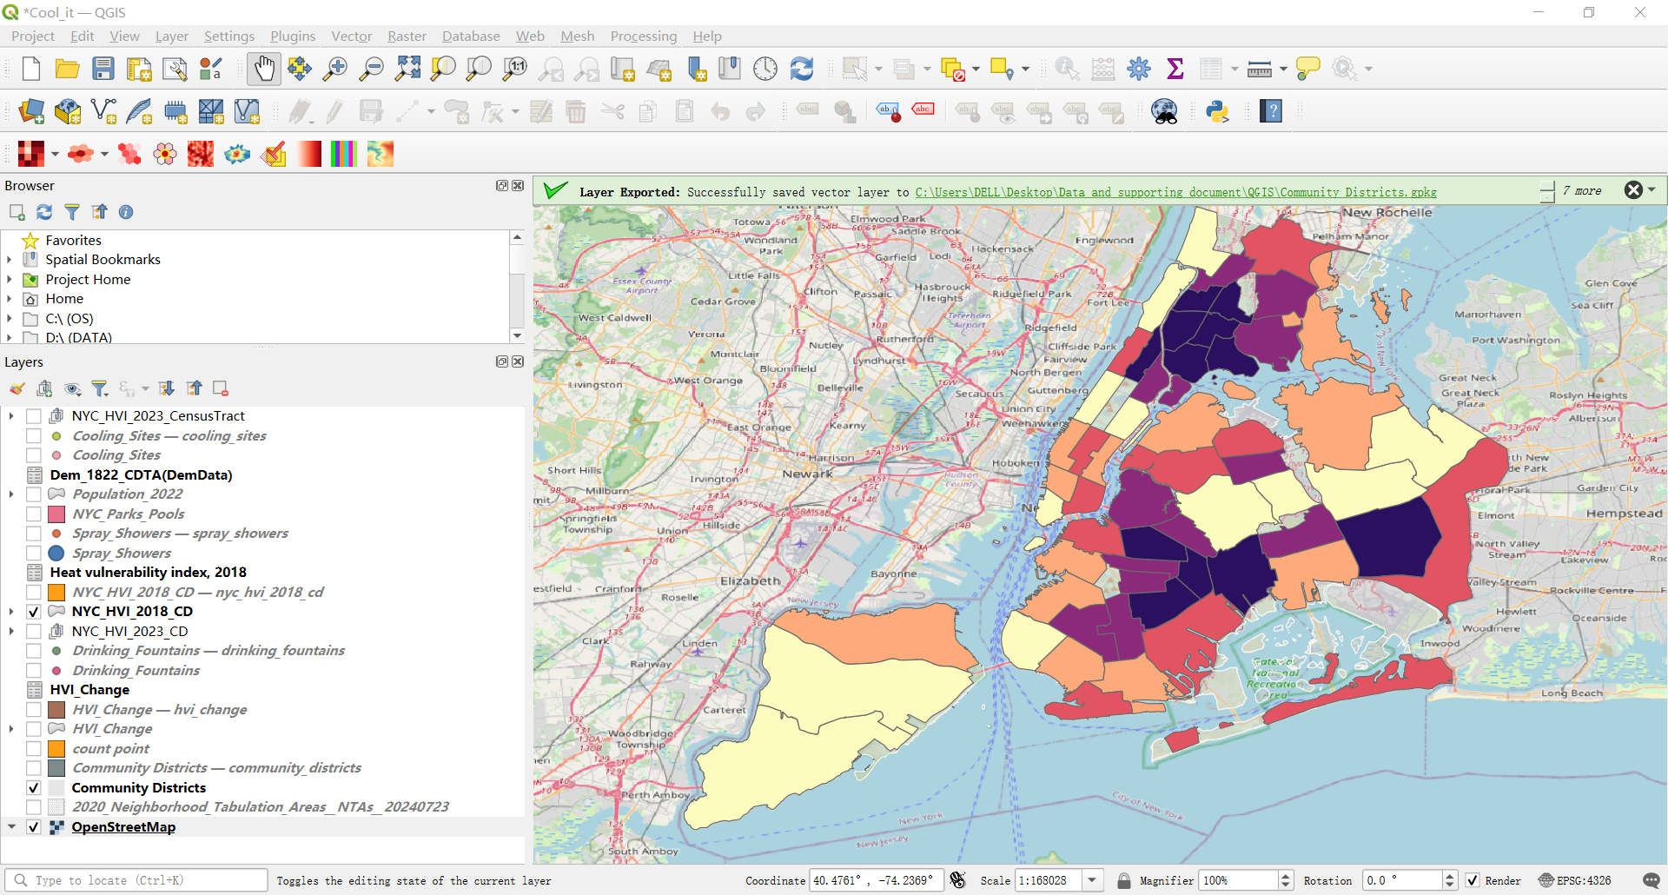

* 1. **Figure 6: Heat Vulnerability Index (HVI) for New York City Community Districts, 2023**

**QGIS Layer: `NYC_HVI_2023_CD`**

**Research Method:**

* Data Source: Heat Vulnerability Index (HVI) data for 2023.
* Visualization Tool: QGIS was used to create the map of HVI scores for 2023.
* Insight: This map provides the current state of heat vulnerability and allows for comparison with 2018 to assess changes.

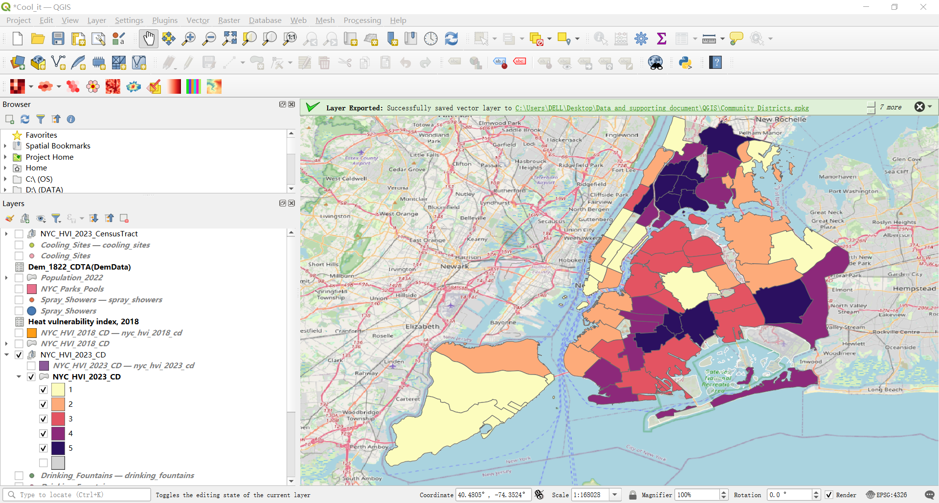

* 1. **Figure 7. HVI Change Map (2018–2023)**

**QGIS Layer: HVI_Change**

**Research Method:**

* Data Source: Heat Vulnerability Index (HVI) data for 2018 and 2023.
* Visualization Tool: QGIS was used to create a map showing changes in HVI scores across New York City between 2018 and 2023.
* Purpose: The map visualizes the changes in heat vulnerability over a five-year period, indicating where the "Cool it! NYC" project has had an impact and where further interventions may be needed.
* Color Coding: Areas in blue indicate a decrease in heat vulnerability, while areas in red represent an increase.
* Distribution: This map helps to identify regions that have experienced significant changes in heat vulnerability, highlighting the effectiveness of cooling interventions and areas that may still be at high risk.

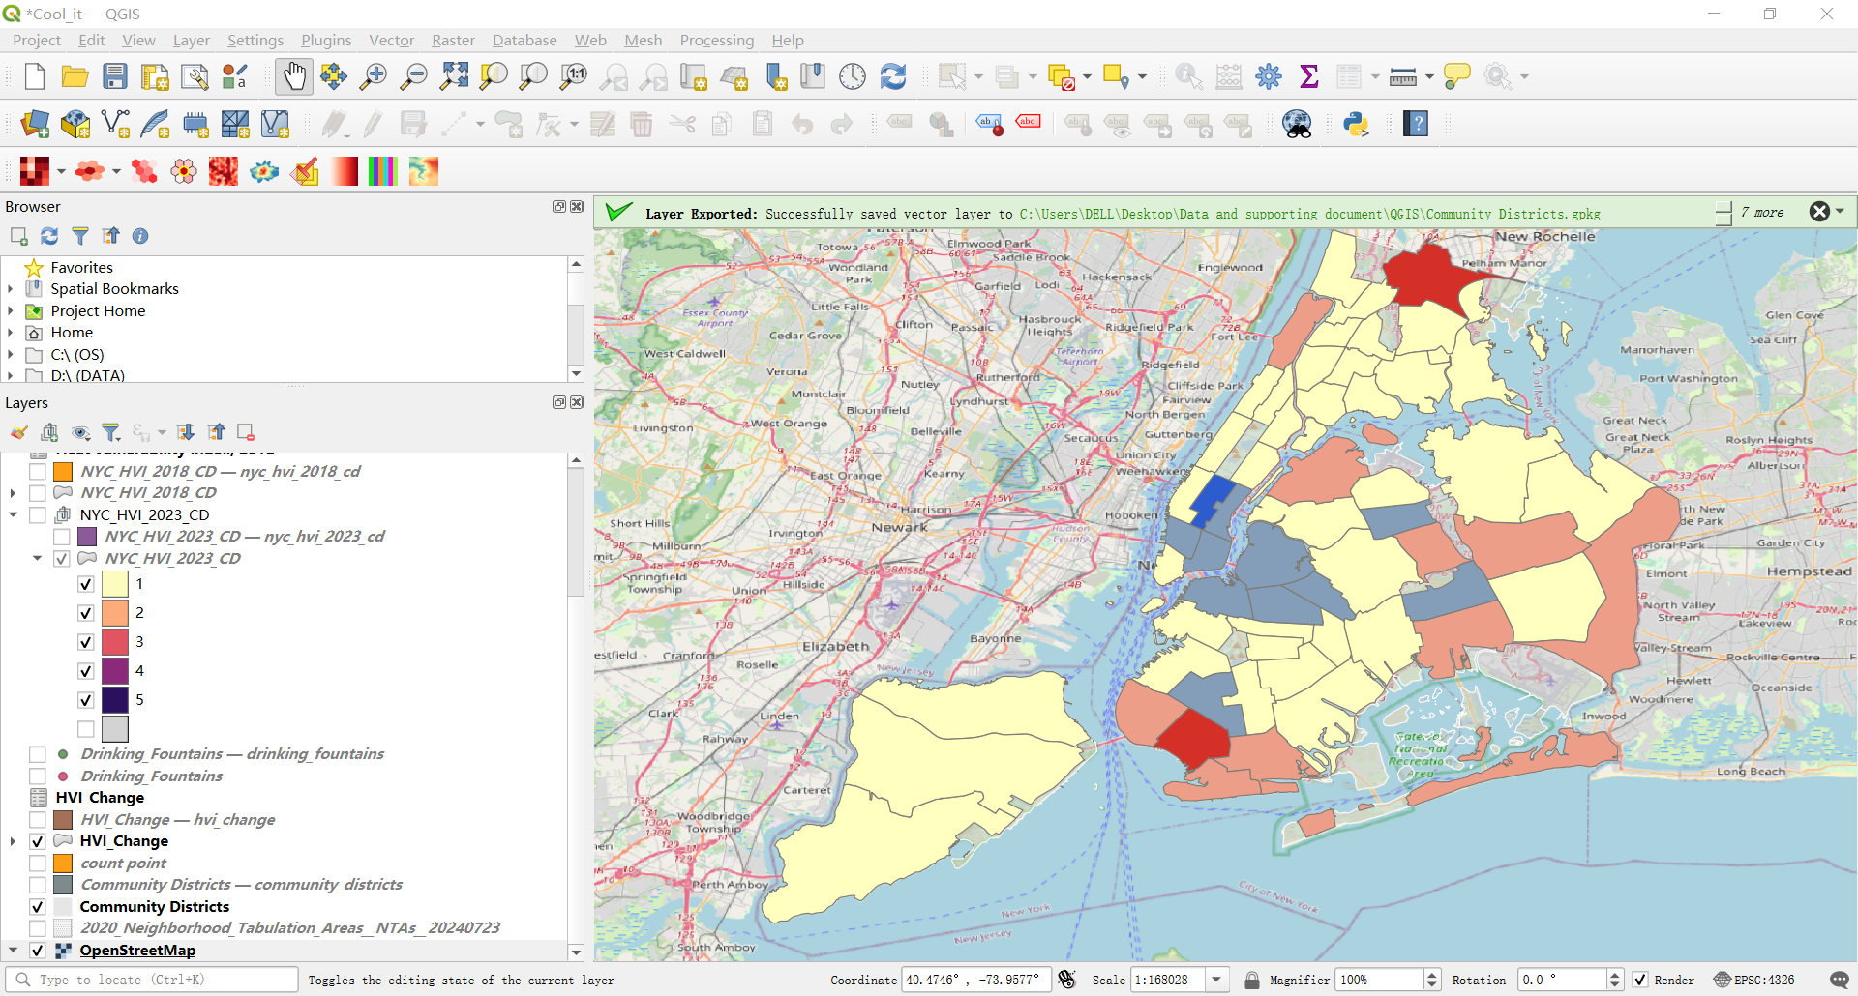

* 1. **Figure 8. Hotspot Map based on cooling facilities**

**QGIS Layers: `Cooling_Sites``Spray_Showers``Drinking_Fountains`**

**Research Method:**

* Data Source: Locations of spray showers, drinking fountains, and cooling sites.
* Analysis Tool: QGIS and the Getis-Ord Gi* statistic were used for hotspot analysis.
* Insight: This map identifies areas with high densities of cooling facilities, indicating where resources are concentrated and where additional facilities may be needed.

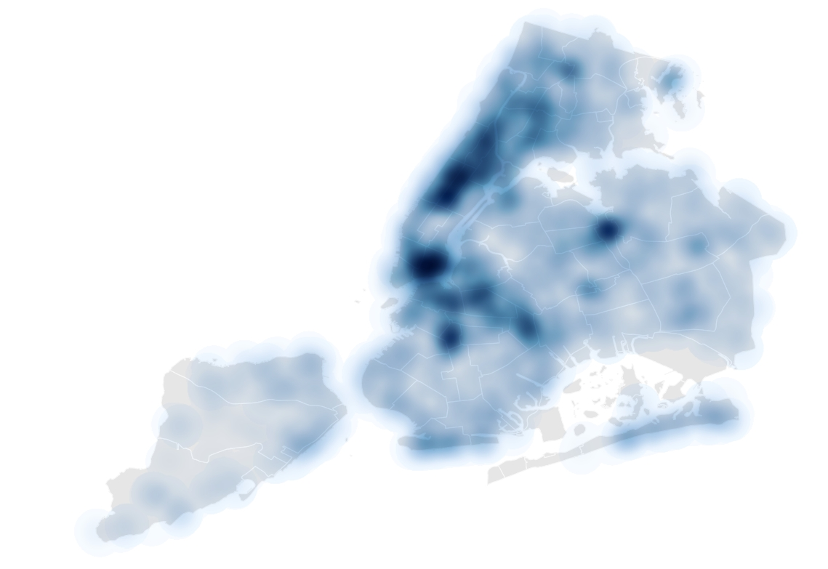

1. **Additional Data Sources and Layers in QGIS**
   1. Population Data: `Population 2022`
   2. Community Districts Boundaries: `Community Districts`
2. **Tables and Metrics**
   1. Table 1: Regression Analysis Summary

**Since this CSV file was integrated locally, I imported it from my local machine. If you need to rerun this code, please first download the HVI_Change.csv file locally, then update the file path in the original code to reflect its saved location. I apologize for any inconvenience this may cause.**

* Dataset: HVI_Change.csv
* Research Method:
  + Data Source: HVI data for 2018 and 2023, locations of cooling facilities.
  + Statistical Tool: Regression analysis was performed using R.
* Metrics:
  + Dependent Variable: Reduction in HVI (2018–2023).
  + Independent Variables: Log-transformed counts of spray showers, drinking fountains, and cooling sites.
  + Model Fit: R-squared value and p-values for each variable.
* Data Summary

The dataset consists of 71 observations with the following key variables:

* BoroCD, Borough, Geography.Name, Label, GeographyID: Identifiers and names of different community districts.
* Shape_Leng, Shape_Area, Shape_Length: Geometric attributes of the community districts.
* X2018_HVI, X2023_HVI, HVI_Change: Heat Vulnerability Index (HVI) scores for the years 2018 and 2023, and the change in HVI.
* Drinking_Fountains_Count, Cooling_Sites_Count, Spray_Showers_Count: Counts of different cooling facilities in each community district.
* Key Descriptive Statistics
* HVI Change: The average change in HVI is close to zero (Mean = 0.0339), indicating minimal overall change across the districts. However, there are variations with some areas experiencing increases (up to +2) and others decreases (down to -2).
* Cooling Facilities: The average numbers of spray showers, drinking fountains, and cooling sites are 10.72, 54.17, and 3.79, respectively. These facilities are distributed unevenly across districts.
* Regression Analysis
* Initial Model (Reduced_HVI_2023): The regression model includes the log-transformed counts of spray showers, drinking fountains, and cooling sites. The coefficient for `Log_Spray_Showers_Count` is positive (0.43829) and marginally significant (p-value = 0.08248). The coefficients for `Log_Drinking_Fountains_Count` (-0.14900) and `Log_Cooling_Sites_Count` (-0.04521) are not significant. The overall model explains about 54.8% of the variance in `Reduced_HVI_2023` (R-squared = 0.548). The p-value for the model is 0.1162, indicating that it is not statistically significant at the 0.05 level.
* Updated Model (Reduced_HVI_2023): This model includes only the significant variable `Log_Spray_Showers_Count`. The coefficient for `Log_Spray_Showers_Count` is 0.26364 and is significant (p-value = 0.0159). The model explains about 49.39% of the variance in `Reduced_HVI_2023` (R-squared = 0.4939). The p-value for the model is 0.01586, indicating that it is statistically significant at the 0.05 level.
* Interpretation
  + Spray Showers: The significant positive coefficient (0.26364) in the updated model suggests that an increase in the number of spray showers is associated with a reduction in the Heat Vulnerability Index (HVI). This implies that spray showers are effective in mitigating heat vulnerability in New York City's community districts.
  + Other Cooling Facilities: The initial model indicates that drinking fountains and cooling sites do not have a significant impact on reducing HVI. These facilities may require further investigation to understand their effectiveness.
* Code:

# Set working directory**(adjust according to your file path)**

setwd("C:/Users/DELL/Desktop/raw data")

# Read CSV data

data <- read.csv("HVI_Change.csv")

# Check data structure and summary

str(data)

summary(data)

# Filter out rows with missing values

data_clean <- data[complete.cases(data), ]

# Add new variables

data_clean$Added_High_HVI <- ifelse(data_clean$HVI_Change > 0, data_clean$HVI_Change, NA)

data_clean$Reduced_HVI_2023 <- ifelse(data_clean$HVI_Change < 0, data_clean$HVI_Change, NA)

# Log-transform variables (add 1 to avoid log of zero)

data_clean$Log_Spray_Showers_Count <- log1p(data_clean$Spray_Showers_Count)

data_clean$Log_Drinking_Fountains_Count <- log1p(data_clean$Drinking_Fountains_Count)

data_clean$Log_Cooling_Sites_Count <- log1p(data_clean$Cooling_Sites_Count)

# Regression analysis - Reduced_HVI_2023

model_reduced <- lm(Reduced_HVI_2023 ~ Log_Spray_Showers_Count + Log_Drinking_Fountains_Count + Log_Cooling_Sites_Count, data = data_clean)

# View regression results

summary(model_reduced)

# Regression analysis with only significant variable - Log_Spray_Showers_Count

model_reduced_updated <- lm(Reduced_HVI_2023 ~ Log_Spray_Showers_Count, data = data_clean)

# View updated regression results

summary(model_reduced_updated)

* Output:

**> # Set working directory (adjust according to your file path)**

**> setwd("C:/Users/DELL/Desktop/raw data")**

**>**

**> # Read CSV data**

**> data <- read.csv("HVI_Change.csv")**

**>**

**> # Check data structure and summary**

**> str(data)**

**'data.frame': 71 obs. of 14 variables:**

**$ BoroCD : int 101 102 103 104 105 106 107 108 109 110 ...**

**$ Borough : chr "Manhattan" "Manhattan" "Manhattan" "Manhattan" ...**

**$ Geography.Name : chr "Financial District (CD1)" "Greenwich Village and Soho (CD2)" "Lower East Side and Chinatown (CD3)" "Clinton and Chelsea (CD4)" ...**

**$ Label : chr "Manhattan CD 1" "Manhattan CD 2" "Manhattan CD 3" "Manhattan CD 4" ...**

**$ GeographyID : int 101 102 103 104 105 106 107 108 109 110 ...**

**$ Shape_Leng : num 73762 34131 30468 67624 35288 ...**

**$ Shape_Area : num 42686525 37689215 46879228 49311713 43790330 ...**

**$ Shape_Length : num 73762 34130 30468 67624 35288 ...**

**$ X2018_HVI : int 1 2 3 2 3 2 1 1 3 5 ...**

**$ X2023_HVI : int 1 1 2 2 1 1 1 1 3 5 ...**

**$ HVI_Change : int 0 -1 -1 0 -2 -1 0 0 0 0 ...**

**$ Drinking_Fountains_Count: int 51 41 142 49 9 34 76 34 52 50 ...**

**$ Cooling_Sites_Count : int 0 0 0 0 0 0 0 1 6 20 ...**

**$ Spray_Showers_Count : int 3 9 28 8 1 5 16 6 13 13 ...**

**> summary(data)**

**BoroCD Borough Geography.Name**

**Min. :101.0 Length:71 Length:71**

**1st Qu.:205.5 Class :character Class :character**

**Median :308.0 Mode :character Mode :character**

**Mean :297.2**

**3rd Qu.:405.5**

**Max. :595.0**

**Label GeographyID Shape_Leng**

**Length:71 Min. :101.0 Min. : 23963**

**Class :character 1st Qu.:203.5 1st Qu.: 36611**

**Mode :character Median :306.0 Median : 52246**

**Mean :280.3 Mean : 74897**

**3rd Qu.:402.5 3rd Qu.: 85711**

**Max. :503.0 Max. :270660**

**NA's :12**

**Shape_Area Shape_Length X2018_HVI X2023_HVI**

**Min. : 24293279 Min. : 23963 Min. :1 Min. :1.000**

**1st Qu.: 48433709 1st Qu.: 36611 1st Qu.:2 1st Qu.:2.000**

**Median : 82702392 Median : 52246 Median :3 Median :3.000**

**Mean :118725441 Mean : 74896 Mean :3 Mean :3.034**

**3rd Qu.:136781173 3rd Qu.: 85711 3rd Qu.:4 3rd Qu.:4.000**

**Max. :599063567 Max. :270652 Max. :5 Max. :5.000**

**NA's :12 NA's :12**

**HVI_Change Drinking_Fountains_Count Cooling_Sites_Count**

**Min. :-2.0000 Min. : 0.00 Min. : 0.000**

**1st Qu.: 0.0000 1st Qu.: 33.00 1st Qu.: 0.000**

**Median : 0.0000 Median : 50.00 Median : 1.000**

**Mean : 0.0339 Mean : 54.17 Mean : 3.789**

**3rd Qu.: 0.0000 3rd Qu.: 70.50 3rd Qu.: 6.000**

**Max. : 2.0000 Max. :179.00 Max. :24.000**

**NA's :12**

**Spray_Showers_Count**

**Min. : 0.00**

**1st Qu.: 6.00**

**Median : 9.00**

**Mean :10.72**

**3rd Qu.:15.00**

**Max. :28.00**

**>**

**> # Filter out rows with missing values**

**> data_clean <- data[complete.cases(data), ]**

**>**

**> # Add new variables**

**> data_clean$Added_High_HVI <- ifelse(data_clean$HVI_Change > 0, data_clean$HVI_Change, NA)**

**> data_clean$Reduced_HVI_2023 <- ifelse(data_clean$HVI_Change < 0, data_clean$HVI_Change, NA)**

**>**

**> # Log-transform variables (add 1 to avoid log of zero)**

**> data_clean$Log_Spray_Showers_Count <- log1p(data_clean$Spray_Showers_Count)**

**> data_clean$Log_Drinking_Fountains_Count <- log1p(data_clean$Drinking_Fountains_Count)**

**> data_clean$Log_Cooling_Sites_Count <- log1p(data_clean$Cooling_Sites_Count)**

**>**

**> # Regression analysis - Reduced_HVI_2023**

**> model_reduced <- lm(Reduced_HVI_2023 ~ Log_Spray_Showers_Count + Log_Drinking_Fountains_Count + Log_Cooling_Sites_Count, data = data_clean)**

**>**

**> # View regression results**

**> summary(model_reduced)**

**Call:**

**lm(formula = Reduced_HVI_2023 ~ Log_Spray_Showers_Count + Log_Drinking_Fountains_Count +**

**Log_Cooling_Sites_Count, data = data_clean)**

**Residuals:**

**Min 1Q Median 3Q Max**

**-0.41087 -0.11165 -0.00344 0.13790 0.29429**

**Coefficients:**

**Estimate Std. Error t value Pr(>|t|)**

**(Intercept) -1.54984 0.35180 -4.405 0.00314**

**Log_Spray_Showers_Count 0.43829 0.21641 2.025 0.08248**

**Log_Drinking_Fountains_Count -0.14900 0.18459 -0.807 0.44611**

**Log_Cooling_Sites_Count -0.04521 0.07951 -0.569 0.58734**

**(Intercept) \*\***

**Log_Spray_Showers_Count .**

**Log_Drinking_Fountains_Count**

**Log_Cooling_Sites_Count**

**---**

**Signif. codes: 0 ‘***’ 0.001 ‘**’ 0.01 ‘*’ 0.05 ‘.’ 0.1 ‘ ’ 1**

**Residual standard error: 0.2423 on 7 degrees of freedom**

**Multiple R-squared: 0.548, Adjusted R-squared: 0.3543**

**F-statistic: 2.829 on 3 and 7 DF, p-value: 0.1162**

**>**

**> # Regression analysis with only significant variable - Log_Spray_Showers_Count**

**> model_reduced_updated <- lm(Reduced_HVI_2023 ~ Log_Spray_Showers_Count, data = data_clean)**

**>**

**> # View updated regression results**

**> summary(model_reduced_updated)**

**Call:**

**lm(formula = Reduced_HVI_2023 ~ Log_Spray_Showers_Count, data = data_clean)**

**Residuals:**

**Min 1Q Median 3Q Max**

**-0.4601 -0.1037 0.0087 0.1626 0.2503**

**Coefficients:**

**Estimate Std. Error t value Pr(>|t|)**

**(Intercept) -1.72266 0.22380 -7.697 3.01e-05 \*\*\***

**Log_Spray_Showers_Count 0.26364 0.08896 2.964 0.0159 \***

**---**

**Signif. codes: 0 ‘***’ 0.001 ‘**’ 0.01 ‘*’ 0.05 ‘.’ 0.1 ‘ ’ 1**

**Residual standard error: 0.2261 on 9 degrees of freedom**

**Multiple R-squared: 0.4939, Adjusted R-squared: 0.4377**

**F-statistic: 8.783 on 1 and 9 DF, p-value: 0.01586**